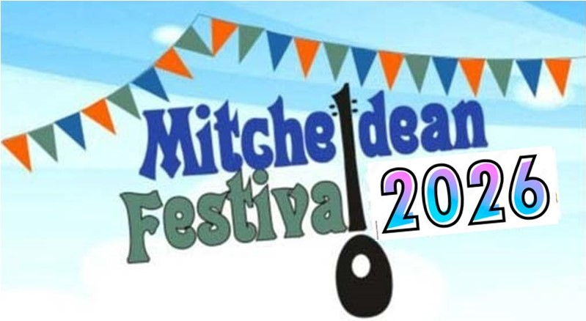

**APPLICATION TO TAKE PART IN A 2025/6**

***MITCHELDEAN FESTIVAL CONCERT EVENT***

**WINTER: Friday 28th November** (Acoustic only) 7.00pm - 9.30pm Mitcheldean Church

**SPRING: Saturday 21st March – Youth** (With PA) 7.00pm - 9.30pm Community Centre

(The Spring event is dedicated to two age groups, Under 18, and 18-30 – please say below which age you are)

**SUMMER: Saturday 13th June** (With PA)7.00pm - 9.30pm Jolters (old Brewery Tap)

**FESTIVAL 1: Friday 17th July** (Acoustic only) 7.00pm - 9.30pm Mitcheldean Church

**FESTIVAL 2: Saturday 18th July** (With PA) 4.00pm - 9.00pm Mitcheldean Church

There will also be informal sessions & **opportunities for busking** in Mitcheldean (18th July, 11.00am onwards). Mitcheldean Festival Concerts are entry-free and will showcase local and visiting acts, providing opportunities for artistes to perform and promote music (all types), songs, and dances. Most acts will be given 20 or 30-minute slots, inclusive of set-up time. We will almost certainly allocate performers to just one concert. Applicants cannot be guaranteed a slot, but we will try to accommodate your requirements, although performers cannot be paid.



If you are interested, please fill in the form below and **return it (no later than Friday 31st October for the Winter concert, or January 30th for the others) to MITCHELDEAN FESTIVAL ORGANISER, either by post to: Mitcheldean Community Library, High Street, Mitcheldean, GL17 0HN or by e-mail to talktous@mitcheldeanfestival.fod.uk.** You will be contacted as soon as possible after the deadlines to confirm arrangements – Many thanks!

------------------------------------------------------------------------------------------------------------------------------------------------

I/we are interested in taking part in a 2025/6 MITCHELDEAN FESTIVAL CONCERT:

Name of act: ___________________________ Name of contact__________________________

Contact address: ________________________________________________________________

Tel. No: ____________________ E-mail: _______________________________________

Number of performers: ______ Instruments: _____________________________________

Do you require amplification/PA? (Circle one): NO / YES / NO PREFERENCE

Description of act:________________________________________________________________

Indicate on the lines provided with a **YES or NO** if you are available to perform at any of the concerts and (if more than one) **tick** just one box to indicate your preference. **Circle** to indicate availability & preferred times/dates.

WINTER (28th Dec 2025): ______ Early / Middle / Late

SPRING (21st June, Youth): ______ Early / Middle / Late

SUMMER (13th June): ______ Early / Middle / Late

FESTIVAL 1 (17th July): ______ Early / Middle / Late

FESTIVAL 2 (18th July): ______ Early / Middle / Late

In addition, are you interested in busking in Mitcheldean on Saturday 18th July? YES / NO

Are you interested in being involved as a Mitcheldean Festival Volunteer helper? YES / NO

(Continue overleaf or on a separate page if necessary)