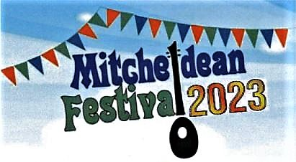

Application to take part in a 2023 Mitcheldean Festival Concert Event

Although venues, dates & times are yet to be confirmed, we aim to hold a range of musical concerts:
PRE-FESTIVAL CONCERT: Saturday 17th June (Acoustic only) Evening (The Lamb)
CONCERT 1: Friday 14th July (Acoustic only) 7.00pm - 9.30pm (Mitcheldean Church)
CONCERT 2: Saturday 15th July (With PA) 4.00pm - 9.00pm (Mitcheldean Church)
There will be other performance opportunities during the Festival weekend (Friday 14th–Sunday 16th July): opportunities for busking in Mitcheldean (15th July, 11.00am onwards) and informal sessions all weekend. We welcome offers of help from anyone who might volunteer to assist with stewarding. Mitcheldean Festival Concerts are entry-free and will showcase local and visiting acts, providing opportunities for artistes to perform and promote music (all types), songs, and dances. Most acts will be given 15-20 minute slots (Concert 1) or 30 minutes (Concert 2), inclusive of set-up time. We will almost certainly allocate performers to just one concert. Applicants cannot be guaranteed a slot but we will try to accommodate your requirements. We will arrange advance publicity and offer refreshments although performers cannot be paid. If you are interested, please fill in the form below and return it (no later than Sunday 19th February) to MF EVENT ORGANISER, either by post to: Edgehill House, Plump Hill, Mitcheldean, GL17 0EY or by e-mail to talktous@mitcheldeanfestival.fod.uk You will be contacted by mid-March to confirm arrangements. For more information, visit the Festival Website at: www.mitcheldeanfestival.fod.uk
------------------------------------------------------------------------------------------------------------------------------------------------
I/we are interested in taking part in a 2023 MITCHELDEAN FESTIVAL CONCERT:

Name of act: ___________________________ Name of contact__________________________
Contact address: ________________________________________________________________
Tel. No: ____________________ E-mail: _______________________________________
Number of performers: ______ Instruments: _____________________________________
Do you require amplification/PA? (Circle one): NO / YES / NO PREFERENCE
Description of act:________________________________________________________________
Indicate on the lines provided with a YES or NO if you are available to perform at any of the concerts and (if more than one) tick just one box to indicate your preference. Circle words to indicate availability & preferred times.
PRE-FESTIVAL CONCERT (17th June): ______ Early / Middle / Late
CONCERT 1 (14th July): ______ Early / Middle / Late
CONCERT 2 (15th July): ______ Early / Middle / Late
In addition, are you interested in busking in Mitcheldean on Saturday 15th July? YES / NO
Are you interested in being involved as a Mitcheldean Festival Volunteer helper? YES / NO

(Continue overleaf or on a separate page if necessary)

