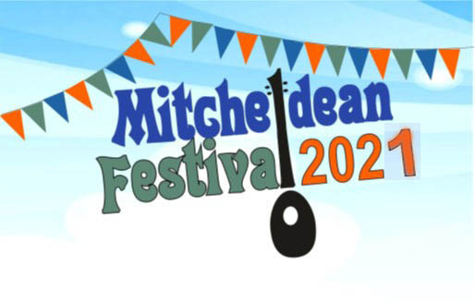
The spectacular success in adverse circumstance of this year’s Young Poets & Story-tellers Competitions will be celebrated at the online Poetry Festival from 2pm on Saturday 17th July, with the full awards ceremony and presentation of prizes held later in the year – see the Mitcheldean Festival Facebook page for more details.

The White Horse and The Lamb plan to be open over the Festival weekend, and the Jolter Press will be open Friday evening and 2-6 pm on Saturday. Unfortunately in light of the delay to the easing of Covid restrictions there will be no events on the playing field this year, but we look forward to holding an event next year.

There will be evening singing performances online on Saturday 17th, but no concerts in the church. Looking ahead to 2022, we would like to have your views on what kind of music you would like to come and hear in the future. There is a short questionnaire overleaf, please let us know your thoughts and preferences.
- What kind of music would you like to come and hear? Please tick all that apply:
- Blues
- Choral
- Classical
- Folk (all kinds)
- Jazz
- Modern Pop
- Rock
- Other (please say)

- Is there a local performer or group you would recommend? Please say.

- Do you know anyone who might like to learn and help on the technical side – sound mixing for bands, p.a. systems etc.? If Yes, please email us at talktous@mitcheldeanfestival.fod.uk
or text / phone Andrew on 07772 053778

- Any other offers to volunteer or suggestions for 2022 welcome, please email as above to talktous@mitcheldeanfestival.fod.uk.

Please hand in your reply where you have picked up this flier, or put it through the Mitcheldean Library letter box, and we look forward to rebuilding your own local Mitcheldean Festival – Many thanks!

