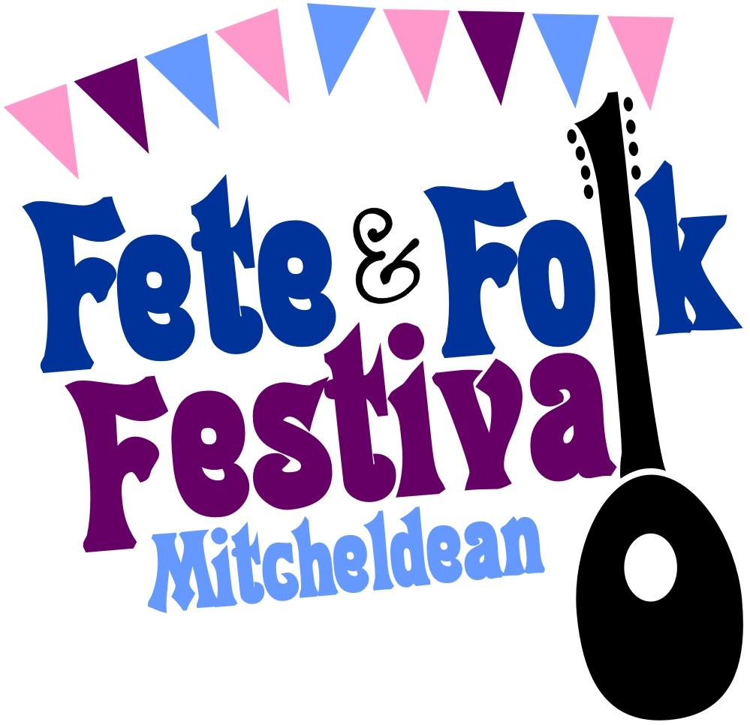
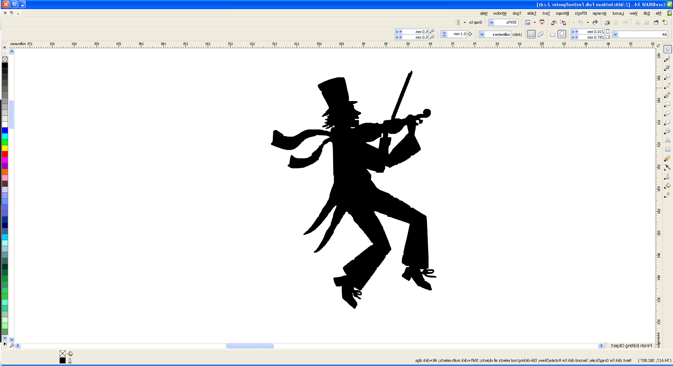
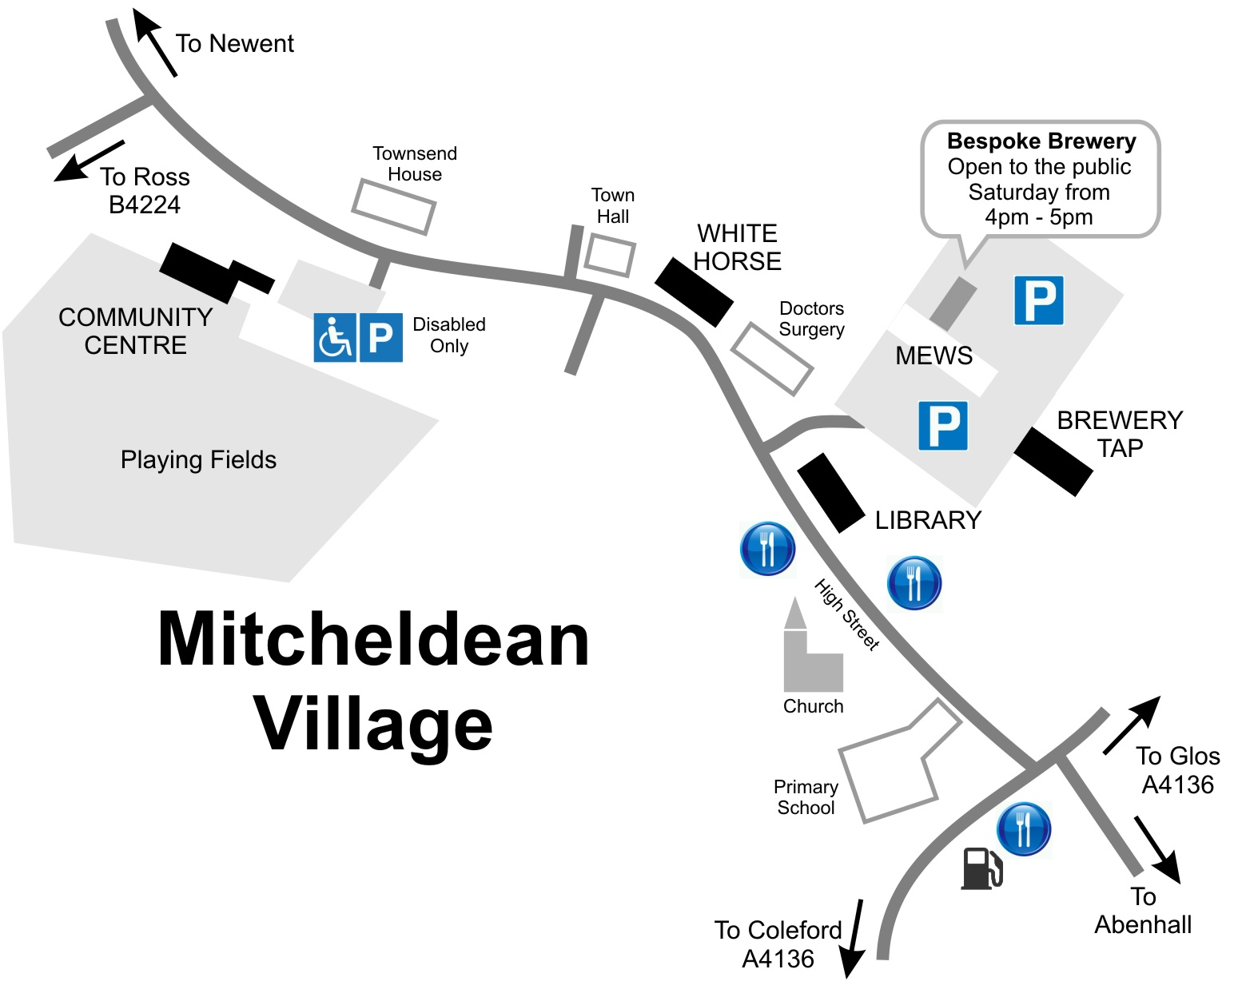


Turn off into Jubilee Road to Oakraven Centre (call Andrew before the weekend for accommodation)

Open during Saturday with a lunchtime barbecue
Programme
Friday 17th – Sunday 19th July
2015
www.mitcheldeanfolkfestival.org.uk
12.00pm
Venue: White Horse
Folk Walk
Join the gang at The White Horse for a walk across the fields to Longhope (approx 7 miles), stopping for drinks and songs at various points along the way. The walk is dog-friendly (although some venues may require them to stay outside), and is fine for all ages provided you can get over a stile or two!
Call Andrew before the weekend on 07772 053778 to book breakfast or a sandwich lunch

For more information and barn dance tickets:
Visit www.mitcheldeanfolkfestival.org.uk
Or call Andrew Maliphant on 07772 053778

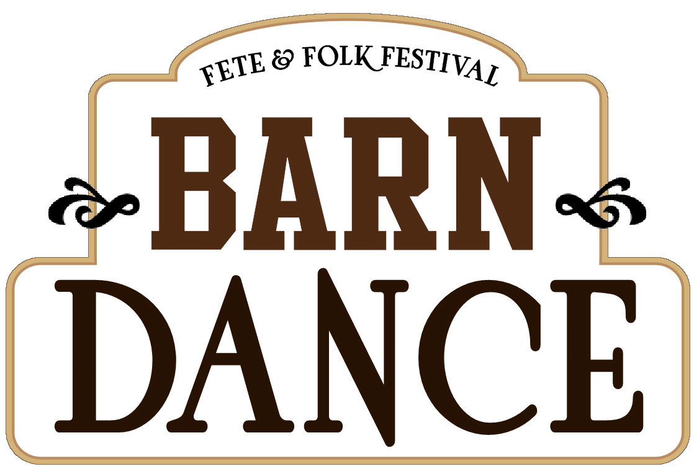
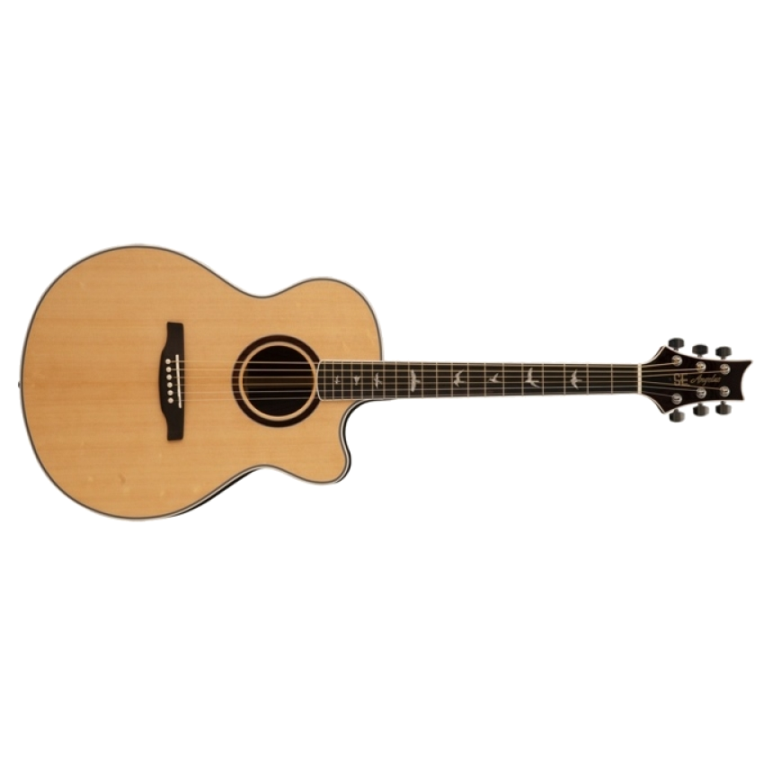





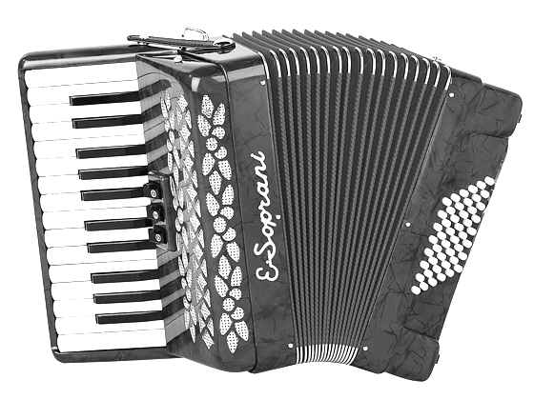
1.00pm – 1.25pm
Showcase Concert Venue: Mitcheldean Parish Church
Peeky Blinders
Acoustic duo play country & folk with a touch of bluegrass
1.30pm – 1.55pm
Tracey Dixon
Powerful & moving songs from this extraordinary Mitcheldean vocalist
2.00pm – 2.25pm
Tommy Lee Fallon
Country music with a mix of original and classic material
2.30pm – 2.55pm
Dave Thompson
One of Mitcheldean’s finest singers and musicians
3.00pm – 3.25pm
Rebecca Kay & Company
Ballads and folk songs with guitar accompaniment
The Library
12.00pm – 4.00pm
Poetry

Join local poets and entertainers for an afternoon of poetry and fun!
Saturday 18th July
7.30pm – 11.00pm
Mitcheldean Community Centre
Venue: Brewery Tap, The MEWS
7.30pm– 11.00pm
Music & Singers
An open mic evening with an eclectic mix of musicians, bands and soloists. Come and sample local ales in the cosy and hospitable atmosphere whilst enjoying the local folk scene.
Visit our Information Desk for updates & Festival info.
10.30pm – 4.00pm
On the streets, in the squares and on the playing fields, local dance groups will clack and jingle.
Various
Morris Dancing
8.00pm – 11.00pm
An informal gathering of musicians and singers around the bar to entertain you.
White Horse
Music & Singers
4.00pm– 4.25pm
Mike and Fiona Taylor
4.30pm – 4.55pm
The Wanted Men
Storytelling & songs with guitars, harmonicas & stomp box
5.00pm – 5.25pm
The Vogwells
Gloucester guitar duo that perform & arrange traditional folk music
5.30pm – 5.55pm
Bygonz
Accomplished guitarist & flautist perform singer/songwriter items from the 60’s & 70’s.
6.00pm – 6.25pm
Clint Mann
Singer/songwriter with indie meets folk guitar thrash
6.30pm – 6.55pm
Sid Harvey
Folk/roots originals with a Gloucestershire twist on guitar, harp & washboard
7.00pm – 7.25pm
Drybrook Male Voice Choir
A male voice group singing a variety of recognisable songs
7.30pm – 8.00pm
May Thrill
8.10pm – 9.00pm
Jules de Bharra & Friends
Distinctive vocal harmonies and accompaniment are on the cards tonight!
Prepare for some songs and tunes from Jules’ gang, and then some further guest appearances and an ensemble performance to round off the evening!
Three musicians & vocalists combine to arrange traditional folk music in their own style
Parking at and near Mitcheldean Mews + Disabled Parking at the Community Centre
Showcase Concert Venue: Mitcheldean Parish Church
Tickets available on the door or in advance by calling Andrew on 07772 053778; Ploughman’s Supper £3.50 booked before the weekend.
12.00pm – 12.50pm
Introduction & School Performers
Thanks for their support go to The Bespoke Brewery, Forest Gate Church, Mitcheldean Parish Church, The White Horse & Mitcheldean Parish Council

3.30pm – 3.55pm
Uke Hunters
Expect Mumford and Sons songs, well known classics and originals from this Lydney ukulele and cajon band
Experience 700 years of English music on the pipe, tabor & hurdy-gurdy
Introduction, crowning of Festival Queen & performances by local schoolchildren
Community Centre & Fields
12.00pm – 4.00pm
Refreshments, Stalls,
Bouncy Castle, Toilets
& St. John’s Ambulance Brigade if you need help.
Fete & Features
Church/High Street
All day
Refreshments, Information & Stalls
Refreshments on sale at the Church. Info and other stalls nearby

